EPA/600/X-24/226|May2024|www.epa.gov/research

CommunityWaterSystemServiceAreas

Documentation

OfficeofResearchandDevelopment

CenterforEnvironmentalSolutionsandEmergencyResponse



Community Water System Service Areas

Documentation by

Andrew Murray & Alex Hall

Center for Environmental Solutions and Emergency Response Cincinnati, OH 45268

Disclaimers

This document is distributed solely for the purpose of pre-dissemination peer review under applicable information quality guidelines. It has not been formally disseminated by the U.S. Environmental Protection Agency. It does not represent and should not be construed to represent any agency determination or policy.

**Table of contents**

**Executive Summary** **1**

SDWIS Reporting Universe 2

**State Data** **4**

**Place Matched Service Area Boundaries** **4**

Mobile Homes - OSM 4

Mobile Homes - Parcels 5

**Modeled Service Area Boundaries** **5**

Binary Water Use Model 5

1:1 Match 8

Random Forest 9

Variables that Describe the Census Block 10

Variables that Describe the Closest Systems 12

Training & Validation 15

**Post Processing** **17**

Hole Filling 17

Polygon Part Removal (Distance) 17

Polygon Part Removal (Area) 18

**Dataset Universe & Known Issues** **18**

Population Served by State 18

Overlapping Boundaries 19

Incorrect Locations 21

Missing Systems 22

Kentucky 23

Florida 23

**Code and Additional Resources** **23**

**Appendix** **24**

Table of systems by Primacy Agency and Method 24

**List of Figures**

|  |  |
| --- | --- |
| 1. Types of Active Systems in SDWA Reporting . . . . . . . . . . . . . . . . . . . . 2. Bar plot showing the count of active community water systems by state, region or | 2 |
| territory. . . . . . . . . . . . . . . . . . . . . . . . . . . . . . . . . . . . . .  3 Visualization of decision tree to predict whether a census block is served by a public | 3 |
| water system. . . . . . . . . . . . . . . . . . . . . . . . . . . . . . . . . . . .  4 example of “matched” 1:1 systems using the graphical regression method. These systems have a strong correlation between housing units (x) and reported service connections (y). The bottom right image shows how census block housing units | 7 |
| are aggregated per unique PWS . . . . . . . . . . . . . . . . . . . . . . . . . .  5 Aerial image showing Microsoft building footprints of a larger two-car garage and a | 9 |
| residential home. Annotations show the garage is just under fifty square meters. .  6 Line and scatter plot showing that as service connections increase, so does the | 11 |
| AUC of the random forest model. . . . . . . . . . . . . . . . . . . . . . . . . .  7 Bar plot showing the percent of population served by state or region that is captured | 17 |
| by service area boundaries. Regions refer to tribal systems within that EPA region. | 19 |
| 8 State boundary (blue) overlapping modeled boundaries (black) . . . . . . . . . . | 20 |
| 1. Map showing areas of overlap within state supplied boundaries. . . . . . . . . . 2. Histogram of systems we do not have boundaries for by the number of service | 21 |
| connections reported under SDWA. binwidth = 10 connections. . . . . . . . . .  11 Bar plot showing the percent of systems missing boundaries by the type of area | 22 |
| they primarily serve. . . . . . . . . . . . . . . . . . . . . . . . . . . . . . . .  **List of Tables**  1 Number of system boundaries from state and municipal sources included in the | 23 |
| ORD dataset. The total number of systems included is 18,374. . . . . . . . . . . | 4 |
| 1. Variables included in decision tree model. . . . . . . . . . . . . . . . . . . . . 2. Confusion matrix showing both decision tree predictions for both the out of bag | 5 |
| testing set and data from Washington. . . . . . . . . . . . . . . . . . . . . . . | 6 |
| 7 Summary statistics of the training and testing sets used to build the random forest. | 16 |

**List of Abbreviations**

|  |  |
| --- | --- |
| Abbreviation | Description |
| CWS | Community Water System |
| HBSL | Health-Based Screening Level |
| HIFLD | Homeland Infrastructure Foundation-Level Data |
| MCL | Maximum Contaminant Level |
| NHGIS | National Historical Geographic Information System |
| OOB | Out-of-Bag |
| ORD | EPA Office of Research and Development |
| OSM | Open Street Map |
| PWSID | Public Water System Identifier |
| SAB | Service Area Boundary |
| SDWA | Safe Drinking Water Act |
| SDWIS | Safe Drinking Water Information System |

# Executive Summary

The Office of Research and Development has released a publicly available dataset of community water system (CWS) service area boundaries (SAB). CWS are defined as systems that provide water for human consumption through pipes or other constructed conveyances to at least 15 service connections or serves an average of at least 25 people year-round (U. EPA 2022) and represent the source of roughly 84% of household drinking water in the United States (Murray et al. 2021). Under the safe drinking water act (SDWA) and various drinking water rules public water systems must test and report on the quality of their drinking water (Act 1974).

While water quality has been a top priority for decades, it remains challenging to determine where households in the United States obtain their drinking water from. There are over 47,000 active community water systems in the United States. Knowing the service areas of these utilities is critical to understanding who is drinking water from where and will enable a link between Safe Drinking Water Act (SDWA) reporting and the populations consuming water from specific utilities.

One study, which sampled 931 public supply wells found that “one or more chemical contaminants were detected at concentrations greater than maximum contaminant levels (MCL) or healthbased screening levels (HBSL) in more than one in five (22 percent)” of sampled wells (Toccalino, Norman, and Hitt 2010). This substantiates the need for federal requirements; these samples were collected prior to treatment. Treatment processes, or dilution can substantially reduce the risk of contaminants getting to the consumer. While federal standards help reduce the likelihood of contaminated drinking water, of the total universe of public water systems in the United States, 6% reported to have violated a health-based drinking water standard and 29% failed to meet at least one monitoring or reporting requirement in 2022 (U. S. EPA 2023).

Community water systems have testing and reporting requirements that may increase based on the size of the system, compliance history and local or state specific requirements. While the source of water for a home may be a primary determinate of its quality, the type of system (private well, small or large community water system) can play an equally important role in the ability for a system to have adequate treatment processes. Private wells, for example, are not regulated by federal law and thus the responsibility for testing and treatment generally falls to the homeowner. It is therefore critical that we understand where people are sourcing their water, who is consuming the water, and how it is delivered to their home in order to more completely understand regional and national trends of water quality and the health impacts to the public.

Using a combination of public data sources, spatial analysis, and machine learning, the Office of Research and Development has developed a national dataset of community water system service areas. Where available, we collect and include publicly available service areas from states. Where service areas are not published, we apply two models to estimate service areas. The first model uses a decision tree method witch uses data from the 1990 and 2020 Census, community water system infrastructure data from SDWIS and land cover data to determine, for each census block, if it is likely to be served by a public water system or by private sources such as domestic wells.

The second model uses a random forest model, with several additional variables to determine, for blocks estimated to be served by public water, the most likely utility to be providing that water. The universe of community water systems is considered current as of 2023 (Quarter 4). Out of a total of 47,538 systems, our dataset includes service areas for 44,415 (93.4%), which represents 99.4% of the total population served by community water systems. At present, this dataset does not include service areas for Puerto Rico or U.S. territories. The data is available from the [EPA Community Water System Service Area Viewer](https://epa.maps.arcgis.com/apps/webappviewer/index.html?id=5a9963ca7a594fbd9b0df40050ed704e)

## SDWIS Reporting Universe

The current ORD dataset (Version 1.0), uses the 2023 (Q4) release of SDWIS data. As of this release, there were a total of 49,396 active community water systems, which primarily serve residential areas (Figure 1). There are many systems, however, which primarily wholesale water to other systems, meaning they do not directly serve water to consumers and therefore do not have a service area boundary. These systems simply source water and deliver it to other systems, who then serve individual customers. The universe of systems in our efforts is limited to currently active community water systems which serve at least 15 service connections or serves an average of at least 25 people for at least 60 days a year. The total number of systems that fit this criteria for 2023 (Q4) is: 47,538. Currently, this dataset does not include service areas for U.S. territories

(Puerto Rico, American Samoa, Guam, Commonwealth of the Northern Mariana Islands, U.S. Virgin

Islands).

Community water systems each fall under a primacy agency (Figure 2), which is the agency with primary responsibility for implementing SDWA, this is typically the state or territory. The exceptions,

where EPA is the primacy agency are Wyoming, the District of Columbia, and federally recognized tribes excluding Navajo Nation. Navajo Nation is currently the only tribe with primacy agency status to enforce SDWA.

Primary Service Area

Subdivision

Residential Area

Other

Municipality

Mobile Home Park

Homeowners Association

0

10,000

20,000

Count of Systems

Primary Service Area

Population Served



50

M

100

M

150

M

200

M

Figure 1: Types of Active Systems in SDWA Reporting

Count of Active Community Water Systems

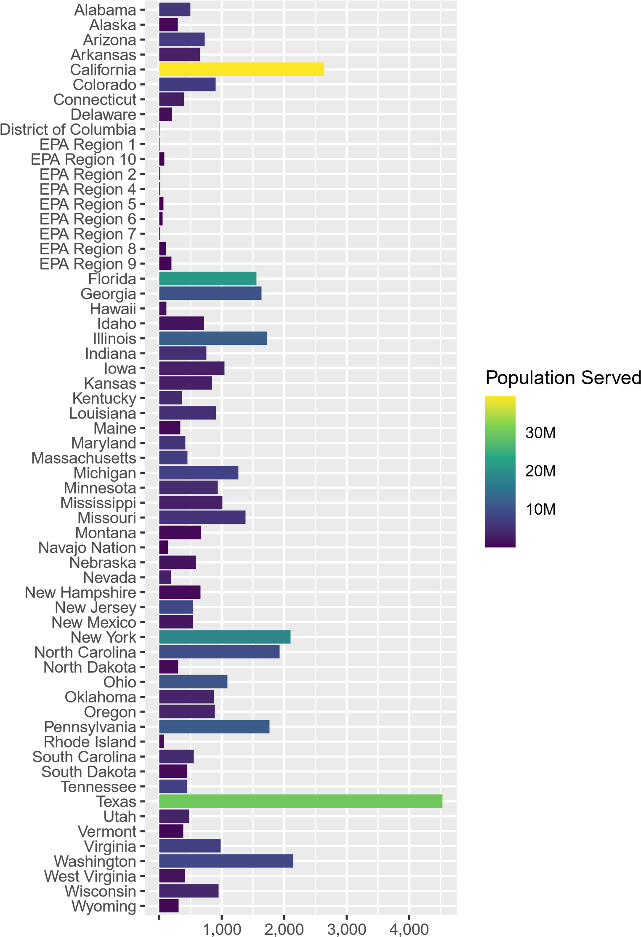 0

Primacy Agency

Count of Systems

Figure 2: Bar plot showing the count of active community water systems by state, region or territory.

Table 1: Number of system boundaries from state and municipal sources included in the ORD dataset. The total number of systems included is 18,374.

|  |  |  |  |  |  |
| --- | --- | --- | --- | --- | --- |
| State | Count of Systems | State | Count of Systems | State | Count of Systems |
| AL | 2 | KS | 781 | NY | 308 |
| AR | 670 | KY | 367 | OH | 1 |
| AZ | 707 | LA | 1 | PA | 1,771 |
| CA | 2,814 | MA | 2 | RI | 31 |
| CO | 3 | MI | 2 | SC | 2 |
| CT | 448 | MS | 361 | TN | 432 |
| DC | 1 | MT | 1 | TX | 4,538 |
| FL | 420 | NC | 482 | UT | 485 |
| GA | 3 | NH | 658 | WA | 1,747 |
| IA | 2 | NJ | 560 | WI | 2 |
| ID | 2 | NM | 532 | WV | 235 |
| IN | 2 | NV | 1 |  |  |

# State Data

When detailed (accurately drawn and not simplified polygons such as county or city boundaries) public water service area boundaries are publicly available from state or municipal sources, we consider those to be authoritative and use them instead of modeled boundaries. A detailed review

was conducted of available data and used to determine what would be included in the ORD national dataset versus what would be modeled (Table 1). Detailed descriptions of state data are available in the supplementary materials.

# Place Matched Service Area Boundaries

## Mobile Homes - OSM

Mobile home parks may represent community water systems that are smaller than a census block, which is the base resolution for the models we create. Therefore, an effort was made to find polygons that represent specific mobile home parks and tie them to their respective community water systems. Areas tagged by Open Street Map (OSM) as ‘residential=trailer_park’, ‘residential=mobile’, or ‘residential=mobile_home_park’ were extracted from Open Street Map and fuzzy name matched

with community water system names reported to SDWIS. To find open street map delineated areas, the point locations for mobile home parks from Homeland Infrastructure Foundation-Level Data (HIFLD) (HIFLD 2023) was intersected with areas tagged as ‘residental=trailer_park’ in open street map. If an intersection occured, the given names of that mobile home park (from both sources) were matched with SDWIS reported names.

## Mobile Homes - Parcels

Where open street map delineated areas were not present, we point locations of mobile home parks were extracted from HIFLD (2023). Points were then intersected with polygon data representing parcels, which were obtained from REGRID (2023). The name of the mobile home park was then fuzzy matched with SDWIS reported system names.

# Modeled Service Area Boundaries

## Binary Water Use Model

A decision tree model was created to determine the probability that a census block is served by a public water system. This model was levered in two different ways: 1.) to aid in the 1:1 matching discussed later and 2.) as a model input (explanatory variable) for the random forest model. The variables included are listed in Table 2.

Table 2: Variables included in decision tree model.

|  |  |
| --- | --- |
| Variable | Description |
| Imperviousness | Urban Imperviousness in percent, derived from the National Land Cover Dataset |
| 2020 Housing Unit Density | Housing units per square kilometer |
| Area | Area in square kilometers |
| % Public Use in 1990 | % of housing units that reported public water use from 1990 Census |
| % Sewer Use in 1990 | % of housing units that reported public sewer use from 1990 Census |
| 1990 Housing Units | Count of housing units in block from 1990 Census |
| % Housing Unit Change 1990-2020 | % change in housing units between 1990 and 2020 Census |
| Distance to Public Water Intake | Distance in kilometers between block centroid and closest public water intake as derived from the Safe Drinking Water Information System |

For census data obtained from the 1990 decennial census, we applied a spatial weighting technique to estimate the number housing units using public water for 1990 census blocks based on published data for census block groups. Census blocks within each block group were ranked from highest housing unit density to lowest housing unit density. The total number of housing units using public water systems was known at the block group level, and this number is then distributed into the most dense census block first, then the next most dense block and so on until no more housing units on public water remain. The remainder of housing units within the less dense blocks are then assumed to be using well water. This method is used because of the statistical relationship that exists between housing unit density and public water use: we know that the densest areas are most Table 3: Confusion matrix showing both decision tree predictions for both the out of bag testing set and data from Washington.

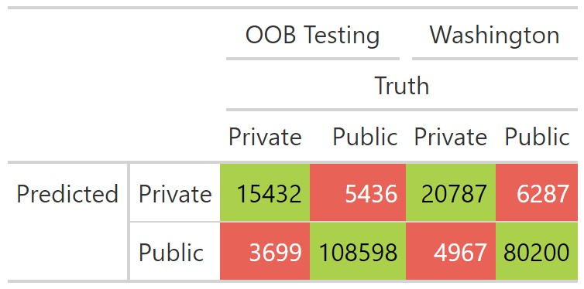

likely to be served by public water. To validate the model, public water systems from three states (New Jersey, Connecticut & California) were joined to census blocks to classify the intersecting blocks as public water users. These three states were chosen based on the completeness and detail of their service area boundaries. The final decision tree model (Figure 3) predicted the type of water supply correctly in 93.14% of blocks in the testing dataset which was removed prior to training. The accuracy of public use (sensitivity) was 95% and the accuracy of private use (specificity) was 81%. A secondary validation was performed using data from Washington, which was never exposed to the model for training (Table 3). We determined the Washington data to be robust and thus it served as both a validation of the model and provided confidence that the model could be applied in states where the model was not trained. For more details on this initial model, refer to the [2020 Water Source Model GitHub Site](https://github.com/USEPA/ORD_Water_Source_2020).

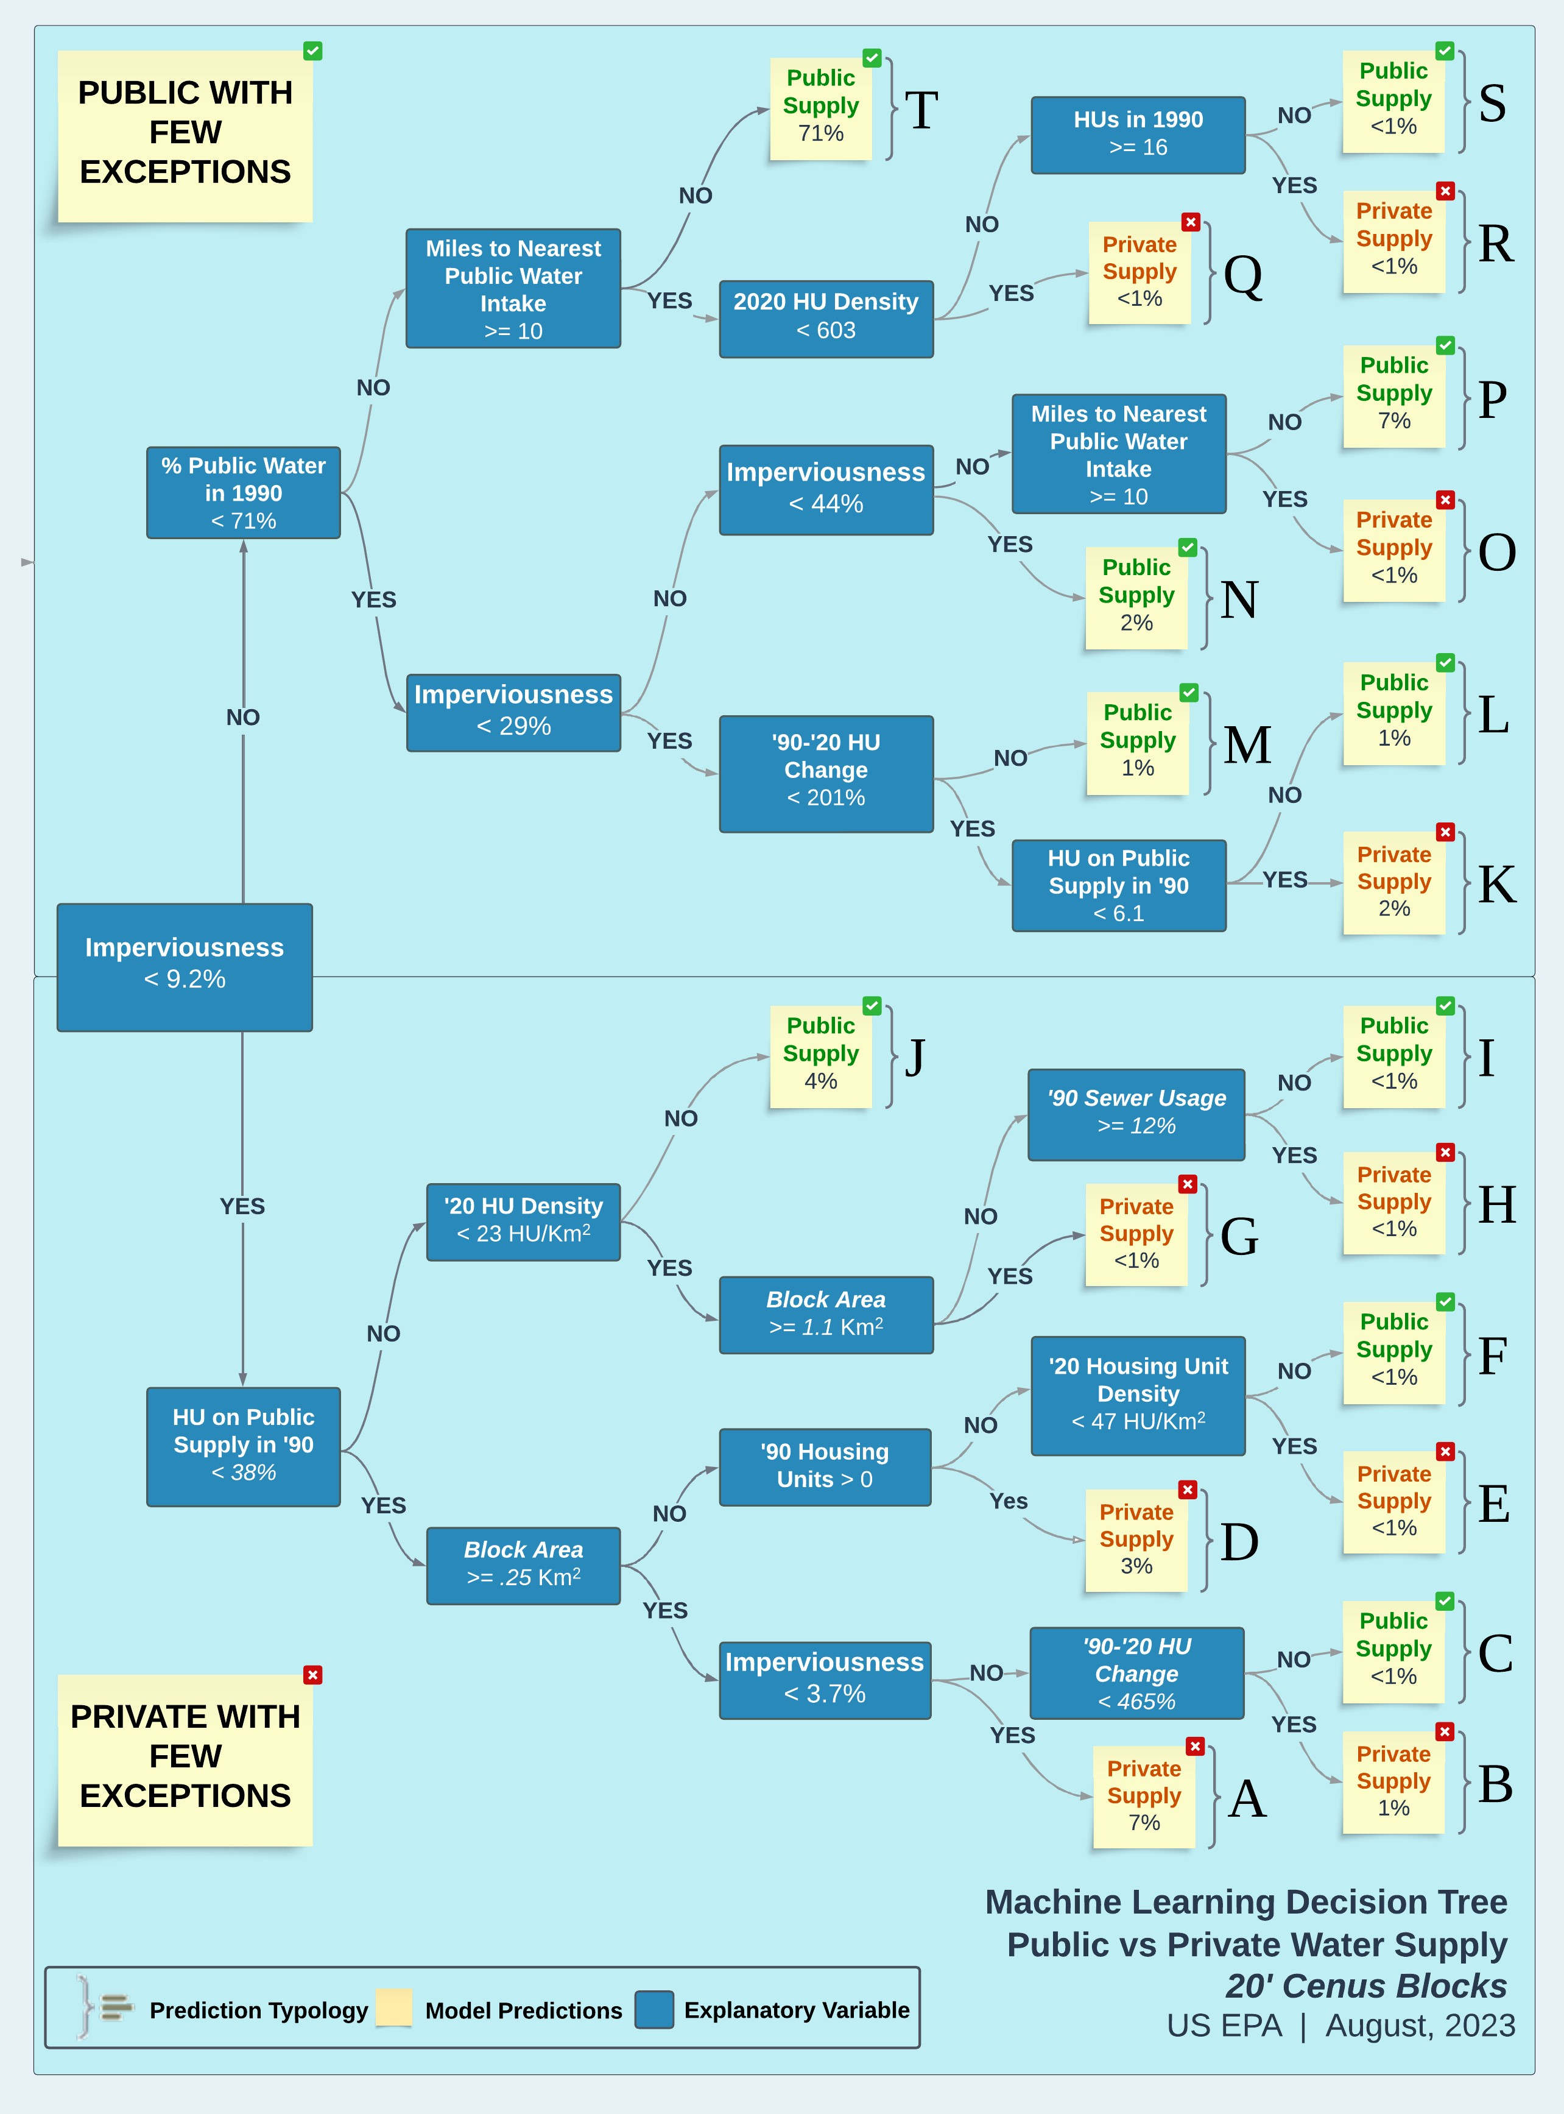

Figure 3: Visualization of decision tree to predict whether a census block is served by a public water system.

## 1:1 Match

Census blocks that are predicted to be served by public water by the binary water use model

(Figure 3) are ‘aggregated’ or ‘dissolved’ spatially, meaning they are combined with any contiguous blocks that are also estimated to be served by public water systems into larger polygons. A public probability threshold of .7 and higher was used to classify block as exclusively on public water. These aggregated polygons are then spatially joined with facility locations from SDWIS, which include intakes, wells, and treatment plants. If a single aggregated area can only be associated

with facilities from a single public water system, that area is assigned its associated PWSID.

As a general approach to modeling, simplicity is typically preferred over complexity. The 1:1 matching was an attempt to resolve system assignments in a very simple way, eliminating the need for more complex random forest modeling. Approximately 8,000 (~17%) systems were assigned (or matched) using this method. This method leveraged the decision tree output to determine system boundary size. Since the model provided confidence levels associated to every block, from 0=confident that that the block is privately supplied; to 1= confident that block is publicly supplied. We found that a value of 0.7 closely approximated the system boundary size and shape when compared to state supplied boundaries. After applying this criteria, we sought to match the system boundaries to their associated PWSID. Spatially continuous blocks were aggregated together into larger polygons.

To determine a match, we used SDWIS locations (wells, treatment plant, intakes) and SDWIS locations (reported system addresses that we geocoded) to conduct a spatial join to the aggregated decision tree boundaries (at 0.7 confidence). The logic here is that for some systems there is only one PWS that serves the polygon area—as opposed to a more complex nested set of systems within a single polygon. More complex systems are mainly associated with urban and suburban areas where the simple systems are largely associated with smaller to mid-size towns in rural areas. The other assumption we had was that it is more likely that a system’s infrastructure is close to the population that it serves than farther away.

We performed a spatial join on all decision tree boundaries and SDWIS locations. If more than one unique system was joined, those boundaries were returned for random forest modeling. If only one PWSID was returned for a polygon we validated that the joins were associated with the correct PWS. To do this we performed a graphical validation method by regressing the service connectionofthejoinedpublicwatersystemagainstthesum2020housingunitswithinthemodeled boundary. Because each state uses a different formula for calculating the service connections, these regressions had to be limited to intra-state comparisons. In other words, the regressions coefficients could vary widely between states, creating an “apples-to-oranges” comparison. The regression was trimmed to systems that fell close to the 1-to-1 regression line. Systems that deviated from that line were removed for later random forest matching. Figure 4 is an example of Iowa systems that were matched using this graphical method for matching systems.

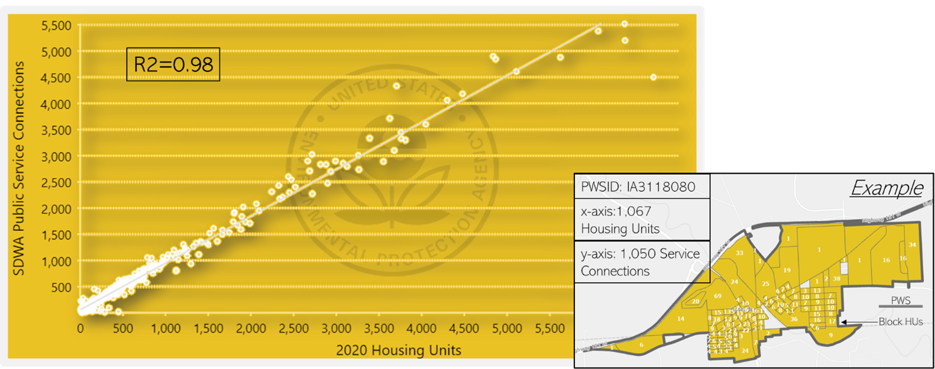

Figure 4: example of “matched” 1:1 systems using the graphical regression method. These systems have a strong correlation between housing units (x) and reported service connections (y). The bottom right image shows how census block housing units are aggregated per unique PWS

## Random Forest

The goal of the random forest model is to be able to determine what public water system (or PWSID) a census block is most likely to be served by. For example, a block in a rural area that is using public water may be more likely to be close to its source water intake if it is a very small system and more likely to be farther away if it a very large rural water district. If you are served by a system that purchases all of its water, the infrastructure may be farther away as well.

The random forest is set up to evaluate the relationship between a single census block and a single point (facility location) associated with a public water system. The tabular data used to train and apply the random forest model has one row for the relationship between every block and every unique PWSID within 25 miles (as determined by CWS infrastructure such as wells, treatment plants, facility addresses, and intakes). As an example, if there are seven different facilities within twenty-five miles of a census block, the table used for the random forest will have seven rows for that census block. Each facility is associated with a parent PWSID. The random forest model then predicts a probability that the parent PWSID is serving the census block in the same row of the table. Predictor variables can be thought of as belonging to one of two groups:

• Variables that that characterize the census block • Variables that characterize the water system.

The random forest model then determines the correct interplay between the variables to determine a probability that a particular system serves a particular census block or is not served by a public water system at all.

### Variables that Describe the Census Block

**Population**

Variable Name: Population

Population is taken from the 2020 Census, obtained at the census block level from ‘2020_DHCa’ downloaded from NHGIS (Manson et al. 2023).

**Local Population Density**

Variable Name: Pop_km

The centroid of each block is buffered by 2 miles (3,218.69 meters). The population density is then calculated as an areal weighted population density of census blocks that intersect the buffer. This variable informs each block of its surroundings—in particular how dense is the nearby city, suburb or rural area.

**Area**

Variable Name: Area_Km

Area is calculated for each block in square kilometers using the Albers equal area projection (crs = 5070).

**Probability of Public Water**

Variable Name: Prob_Pub

The probability (0-1) of a block being served by public water as estimated from the ORD water use decision tree model (Figure 3).

**Buildings**

Variable Name: nBuildings

The number of buildings within a census block that are greater then 50 square meters in area. This is calculated using Microsoft building footprints (Microsoft 2023). We use a cutoff of 50 square meters to remove smaller buildings such as detached garages and sheds (Figure 5).

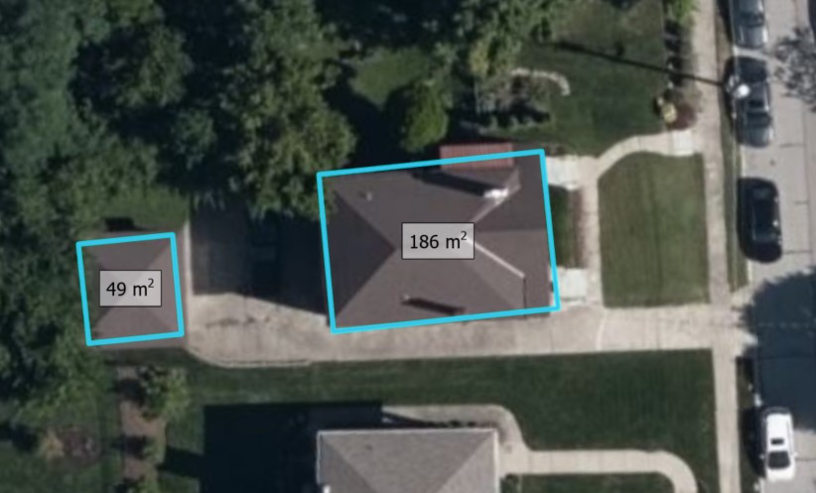

Figure 5: Aerial image showing Microsoft building footprints of a larger two-car garage and a residential home. Annotations show the garage is just under fifty square meters.

**Percent Buildings**

Variable Name: PctBldg

The percent area of the census block that is covered by buildings. This is calculated as the total area of microsoft building footprints divided by the area of the census block (Microsoft 2023).

**Mean Building Area**

Variable Name: meanBldg_m

The mean area in square meters of buildings within the census block (Microsoft 2023).

**Minimum Building Area**

Variable Name: minBldg_m

The area in square meters of the smallest building within the census block (Only buildings greater than or equal to 50 square meters included) (Microsoft 2023).

**Maximum Building Area**

Variable Name: maxBldg_m

The area in square meters of the largest building within the census block (Only buildings greater than or equal to 50 square meters included) (Microsoft 2023).

**Standard Deviation of Building Area** Variable Name: sdBldg_m

The standard deviation of area of buildings in square meters within a census block (Microsoft 2023).

**Rural / Urban**

Variable Name: PctRural

The census defined urban / rural classifier; A binary classification, in which to qualify as an urban area, the block identified must encompass at least 2,000 housing units or have a population of at least 5,000 for 2020 (census block level). The dataset used is ‘Urban and Rural’ from ‘2020_DHCa’ at the census block level, obtained from NHGIS (Manson et al. 2023)

**Mean Residential Acres**

Variable Name: meanResAcres

The mean value in acres of parcels within the census block that are zoned for residential use (REGRID 2023).

**Count of Parcels**

Variable Name: nParcels

The total count of parcels within the census block (REGRID 2023).

**Count of Mobile Homes**

Variable Name: MH_Count

The count of mobile home communities within a census block as derived from the Homeland Infrastructure Foundation Level database (HIFLD 2023).

**Mobile Home Size**

Variable Name: MH_Size

The cumulative size of mobile home parks within a census block representing the number of mobile home units (HIFLD 2023). This variable is presented as a factor.

**Possible Values:**

|  |  |
| --- | --- |
| Value | Description |
| ‘50’ | <50 Mobile Homes |
| ‘75’ | 50-100 Mobile Homes |
| ‘100’ | >100 Mobile Homes |

### Variables that Describe the Closest Systems

**Distance**

Variable Name: Facility_Dist The distance in meters between the census block centroid and a single point from SDWIS for a system.

**Distance Rank**

Variable Name: Dist_Rank

Describes the closeness rank of the particular facility being measured to. For example, if Dist_Rank = 5, there would be 4 other facility points closer to the centroid of that census block.

**Facility Type**

Variable Name: Facility_Type

The type of system point that was used in the distance calculation. Options include:

* “Well”
* “Treatment Plant”
* “Consecutive Connection”
* “Intake”
* “Other”

The ‘Other’ Category contains less frequent data and data used when there are no wells, intakes or treatment plants associated with a system. Some examples of less frequent locations are springs, reservoirs and infiltration zones. This class also contains the administrative contact addresses of systems as reported to SDWIS which are typically within a service area but are also known to be unreliable depending on the system. Administrative contact addresses were geolocated and curated to only include street intersections or better.

**Population Served**

Variable Name: Population_Served_Count

The reported population that is served by the system in SDWIS reporting.

**Connections**

Variable Name: Service_Connections_Count

The reported number of service connections within a system in SDWIS reporting.

**Distance to Center of System**

Variable Name: Ctr_Dist

If a system has more than one SDWIS point (intakes, wells treatment plants etc…) the mean center of all points is calculated and measured in meters from the centroid of the census block. If only one point exists within a system, this value will be identical to Facility_Dist.

**System Type**

Variable Name: Service_Area_Type

The Primary type of area that is served by the public water system.

**Possible Values:**

* ‘Homeowners Association’
* ‘Mobile Home Park’
* ‘Multiple’
* ‘Municipality’
* ‘Other’
* ‘Residential Area’
* ‘Subdivision’

**Sub-County Match**

Variable Name: SubCounty_Match

Reflects a classified Jaro-Winkler string distance between the census place the census block is within and the ‘City Served’ of the public water system associated with the point being measured to.

|  |  |
| --- | --- |
| Jaro-Winkler Distance | Classification |
| <0.1 | “Full Match” |
| >0.1 & <0.3 | “Partial Match” |
| ≥0.3 | “No Match” |
| if no census sub county | “No SubCounty” |
| if no city served | “No City Served” |

**Place Match**

Variable Name: Place_Match

Reflects a classified Jaro-Winkler string distance between the census place the census block is within and the ‘City Served’ of the public water system associated with the point being measured to.

|  |  |
| --- | --- |
| Jaro-Winkler Distance | Classification |
| <0.1 | “Full Match” |
| >0.1 & <0.3 | “Partial Match” |
| ≥0.3 | “No Match” |
| if no census place | “No Place” |
| if no city served | “No City Served” |

**County Match**

Variable Name: County_Match

A categorical value denoting whether the county that the census block is within matches a county reported to be served by the system being measured.

**Possible Values:**

* ‘Match’
* ‘No Match’
* ‘No County’

**Place Name Present in System Name** Variable Name: Place_in_PWS

A measure of how much of the system name also appears in the census place name that the census block is within. The longest common sub-string (LCS) is calculated between the census place and the system name and is then using the formula:

(𝑝𝑤𝑠𝑁𝑎𝑚𝑒𝑙𝑒𝑛𝑔𝑡ℎ − 𝐿𝐶𝑆)/𝑃𝑙𝑎𝑐𝑒𝑙𝑒𝑛𝑔𝑡ℎ

where 𝑝𝑤𝑠𝑁𝑎𝑚𝑒𝑙𝑒𝑛𝑔𝑡ℎ is the length of the place name string in characters, 𝑃𝑙𝑎𝑐𝑒𝑙𝑒𝑛𝑔𝑡ℎ is the length of the public water system name in characters and 𝐿𝐶𝑆 is the length of the longest common sub-string between the two. An exact match would result in a value of 1. If either string is missing, a value of zero is assigned.

**Sub-County Name Present in System Name** Variable Name: SC_in_PWS

A measure of how much of the system name also appears in the census sub-county name that the census block is within. The longest common sub-string (LCS) is calculated between the census sub-county and the system name and is then using the formula:

(𝑝𝑤𝑠𝑁𝑎𝑚𝑒𝑙𝑒𝑛𝑔𝑡ℎ − 𝐿𝐶𝑆)/𝑆𝑢𝑏𝐶𝑜𝑢𝑛𝑡𝑦𝑙𝑒𝑛𝑔𝑡ℎ

where𝑝𝑤𝑠𝑁𝑎𝑚𝑒𝑙𝑒𝑛𝑔𝑡ℎ isthelengthofthesub-countynamestringincharacters, 𝑆𝑢𝑏𝐶𝑜𝑢𝑛𝑡𝑦𝑙𝑒𝑛𝑔𝑡ℎ is the length of the public water system name in characters and 𝐿𝐶𝑆 is the length of the longest common sub-string between the two. An exact match would result in a value of 1. If either string is missing, a value of zero is assigned.

### Training & Validation

The random forest is applied to every census block that is not covered by an authoritative boundary (i.e. state dataset) or captured by the 1:1 or mobile home methods, and returns a probability for each facility location (excluding systems where authoritative and 1:1 boundaries exist) within 25 miles of each census block. That probability can be interpreted as the probability that the system PWSID associated with that facility is serving public water to that census block. A full comparison between the training and testing sets is shown in Table 7

The data used to build the random forest model was split randomly across Arizona, Arkansas, California, Connecticut, New Jersey and Texas into training and testing sets (Table 7). These six states were chosen due to their relative accuracy and completeness when inspected and evaluated against the current universe of active community water systems. Data is split into separate sets so the relationships constructed by the random forest model can be evaluated against data it has not been exposed to (out-of-bag sample).

Table 7: Summary statistics of the training and testing sets used to build the random forest.

|  |  |  |
| --- | --- | --- |
|  | Training Set | Testing Set |
| # Rows | 3.1 Million | 47 Million |
| # Census Blocks | 760 Thousand | 1.1 Million |
| # Correct | 350 Thousand | 4.2 Million |
| # Incorrect | 2.8 Million | 42.7 Million |
| # Systems | 1.7 Thousand | 1.7 Thousand |

The random forest model was tuned on the number of trees and the value of m-try (the number of random variables considered at each split). The final model used a forest of fifty decision trees with 𝑚𝑡𝑟𝑦 = 20. The out-of-bag testing set returned 4,201,409 ‘TRUE’ predictions (the system PWSID is correct) and 42,738,447 ‘FALSE’ predictions (the system PWSID is not correct) and predicted 99.7% of rows correctly. The sensitivity (accuracy of true positives) was 98.38% and the specificity (accuracy of true negatives) was 99.83%. The kappa value for the entire testing set was 0.982.

The area under the curve (AUC) was calculated for the entire training set, as well as subsets based on the number of service connections of candidate systems for each census block (Figure 6). The global auc for the testing set was 0.9997. The model AUC does decline as systems become smaller.

The AUC for systems with service connections less than 500 was 0.9962.

0.996

0.997

0.998

0.999

0

100

K

200

K

300

K

400

K

Service Connections

AUC

Figure 6: Line and scatter plot showing that as service connections increase, so does the AUC of the random forest model.

# Post Processing

The random forest model was post processed to simplify the boundary results and remove spatial outliers.

## Hole Filling

Random forest outputs were spatially aggregated from the census block to the PWSID. To overcome spatial issues, such as interstate highways and right-of-ways, blocks were buffered by one-hundred meters, dissolved on the PWSID, then negatively buffered by one-hundred meters to conserve the correct footprint. A function to remove interior holes (Dorman 2022).

## Polygon Part Removal (Distance)

For random forest outputs, if a system had more than one polygon that did not connect, we measured the distance between the largest polygon for the system and each of the satellite polygons. If the satellite polygon was more than ten kilometers away and had a lesser probability than the primary polygon, it was deleted.

## Polygon Part Removal (Area)

It was discovered that there were many small “artifacts” the model created: small in size and mostly isolated blocks that were relatively far away from where their parent (primary—or largest) system boundary was located. To carefully remove these, the features were ‘exploded’ so unique polygon parts could be examined individually. Before ‘explosion’, the total aggregate system size was calculated (Km2). The exploded polygon parts size was then calculated (Km2), and each polygon part area was divided by the total system area in order to get a percent of total area. To remove these fragments, a threshold was applied: any polygon part that was less than 20% of the total system area and was less than 3 km2 in size was removed. This eliminated some 100k polygon parts. After this procedure, only ~48,000 polygon parts remained (close to the number of total systems—suggesting most systems now only have 1 polygon per system.

# Dataset Universe & Known Issues

The universe of systems we attempt to model is 47,952 systems. We were able to model or gather state supplied boundaries for 42,743 systems (89%). The unmatched systems predominately serve relatively small populations. This is proven when we calculate the percent of the population served by modeled boundaries vs the universe of systems: 98.3%. This high percentage gives us confidence that we are capturing the service area boundaries for most people reliant on public water. Figure 7 shows the percent of modeled/state supplied boundaries and their percent population served of the total universe.

We remove any system that serves less than 25 people or has less than 15 service connections

(unless we were able to model them or they were state supplied)[1]. These systems are typically sub-block in size and cannot reasonably be modeled. A large majority of these systems also did not meet the federal definition of a public water system.

Systems that are exclusively wholesalers of water were also removed from the universe because these systems don’t distribute water to customers—and thus have no service area boundaries. Puerto Rico and US territory systems are not included because explanatory data for model inputs are not available for these geographies.

The final output dataset includes 44,415 systems out of a universe of 47,538 (93.4%)

## Population Served by State

The modeled boundaries represent 98.3 % of the population served as reported in SDWIS (Figure 7).

% Population Served

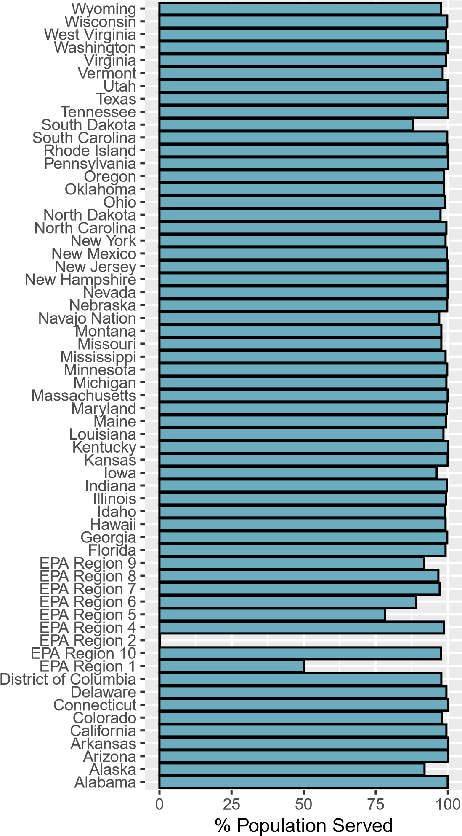

Primacy Agency

Figure 7: Bar plot showing the percent of population served by state or region that is captured by service area boundaries. Regions refer to tribal systems within that EPA region.

## Overlapping Boundaries

Within the final dataset there are instances where two or more boundaries occupy the same area. Theoretically two or more systems can occupy a single block (the spatial scale of the model) but this is known to be rare. Overlaps usually occur in two scenarios:

1. State boundaries overlapping modeled boundaries: Figure 8 shows an example of areas in Des Moines where boundaries overlap. Altoona, IA (modeled) overlaps the state supplied boundary of Des Moines. In this example the modeled boundary for Altoona appears correct. Altoona has a unique PWS. However, the state supplied boundary didn’t “erase” the Altoona system from the service area. This conflict is likely a function of inaccurate state supplied boundaries.

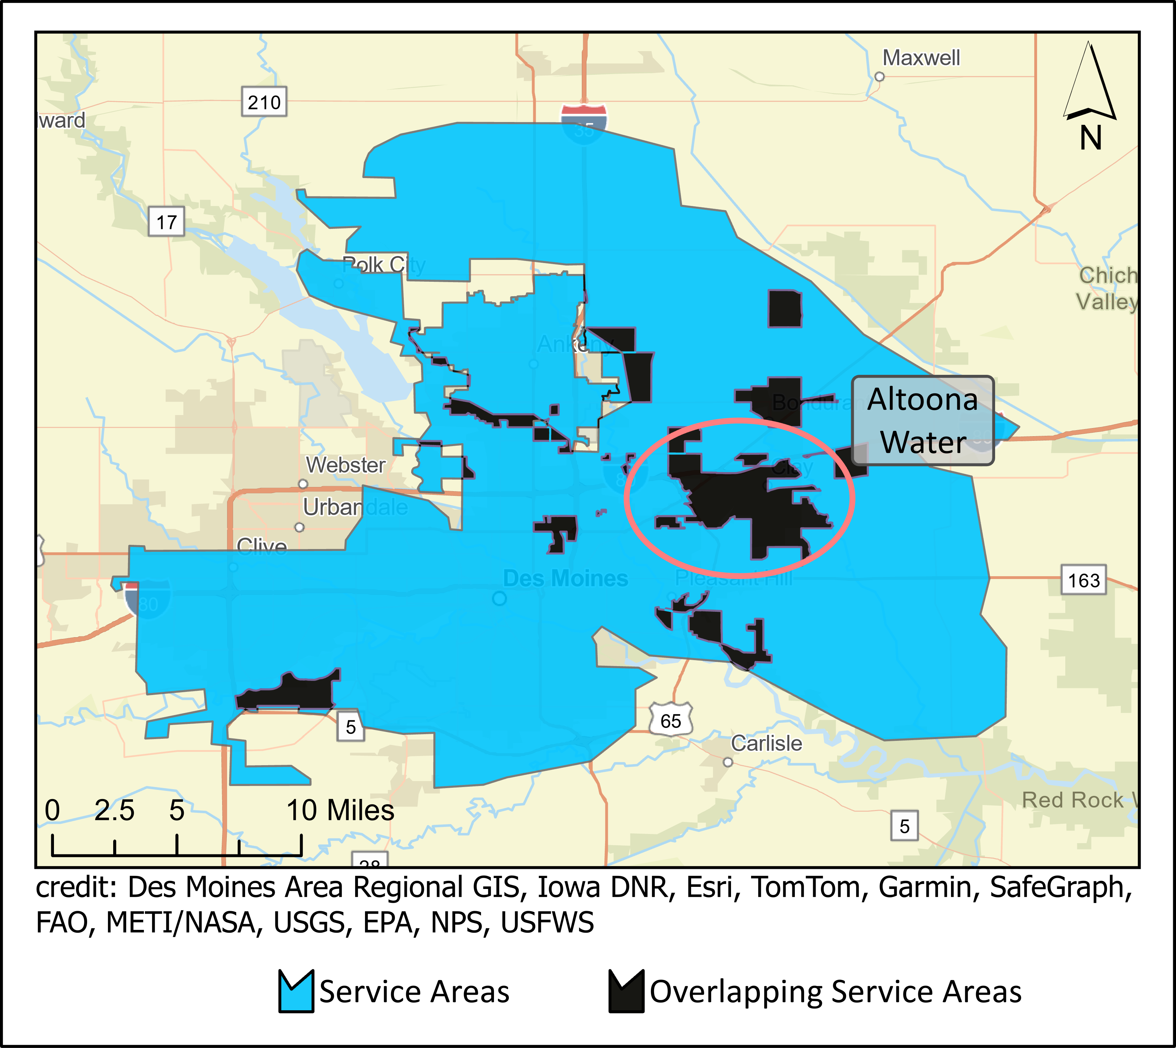

Figure 8: State boundary (blue) overlapping modeled boundaries (black)

1. State boundaries overlapping other state boundaries: Figure 9 shows an example of multiple state systems overlapping each other. Because these are state supplied boundaries, nothing can be done to resolve this issue. They are either incorrectly drawn or multiple systems serve approximately the same areas.

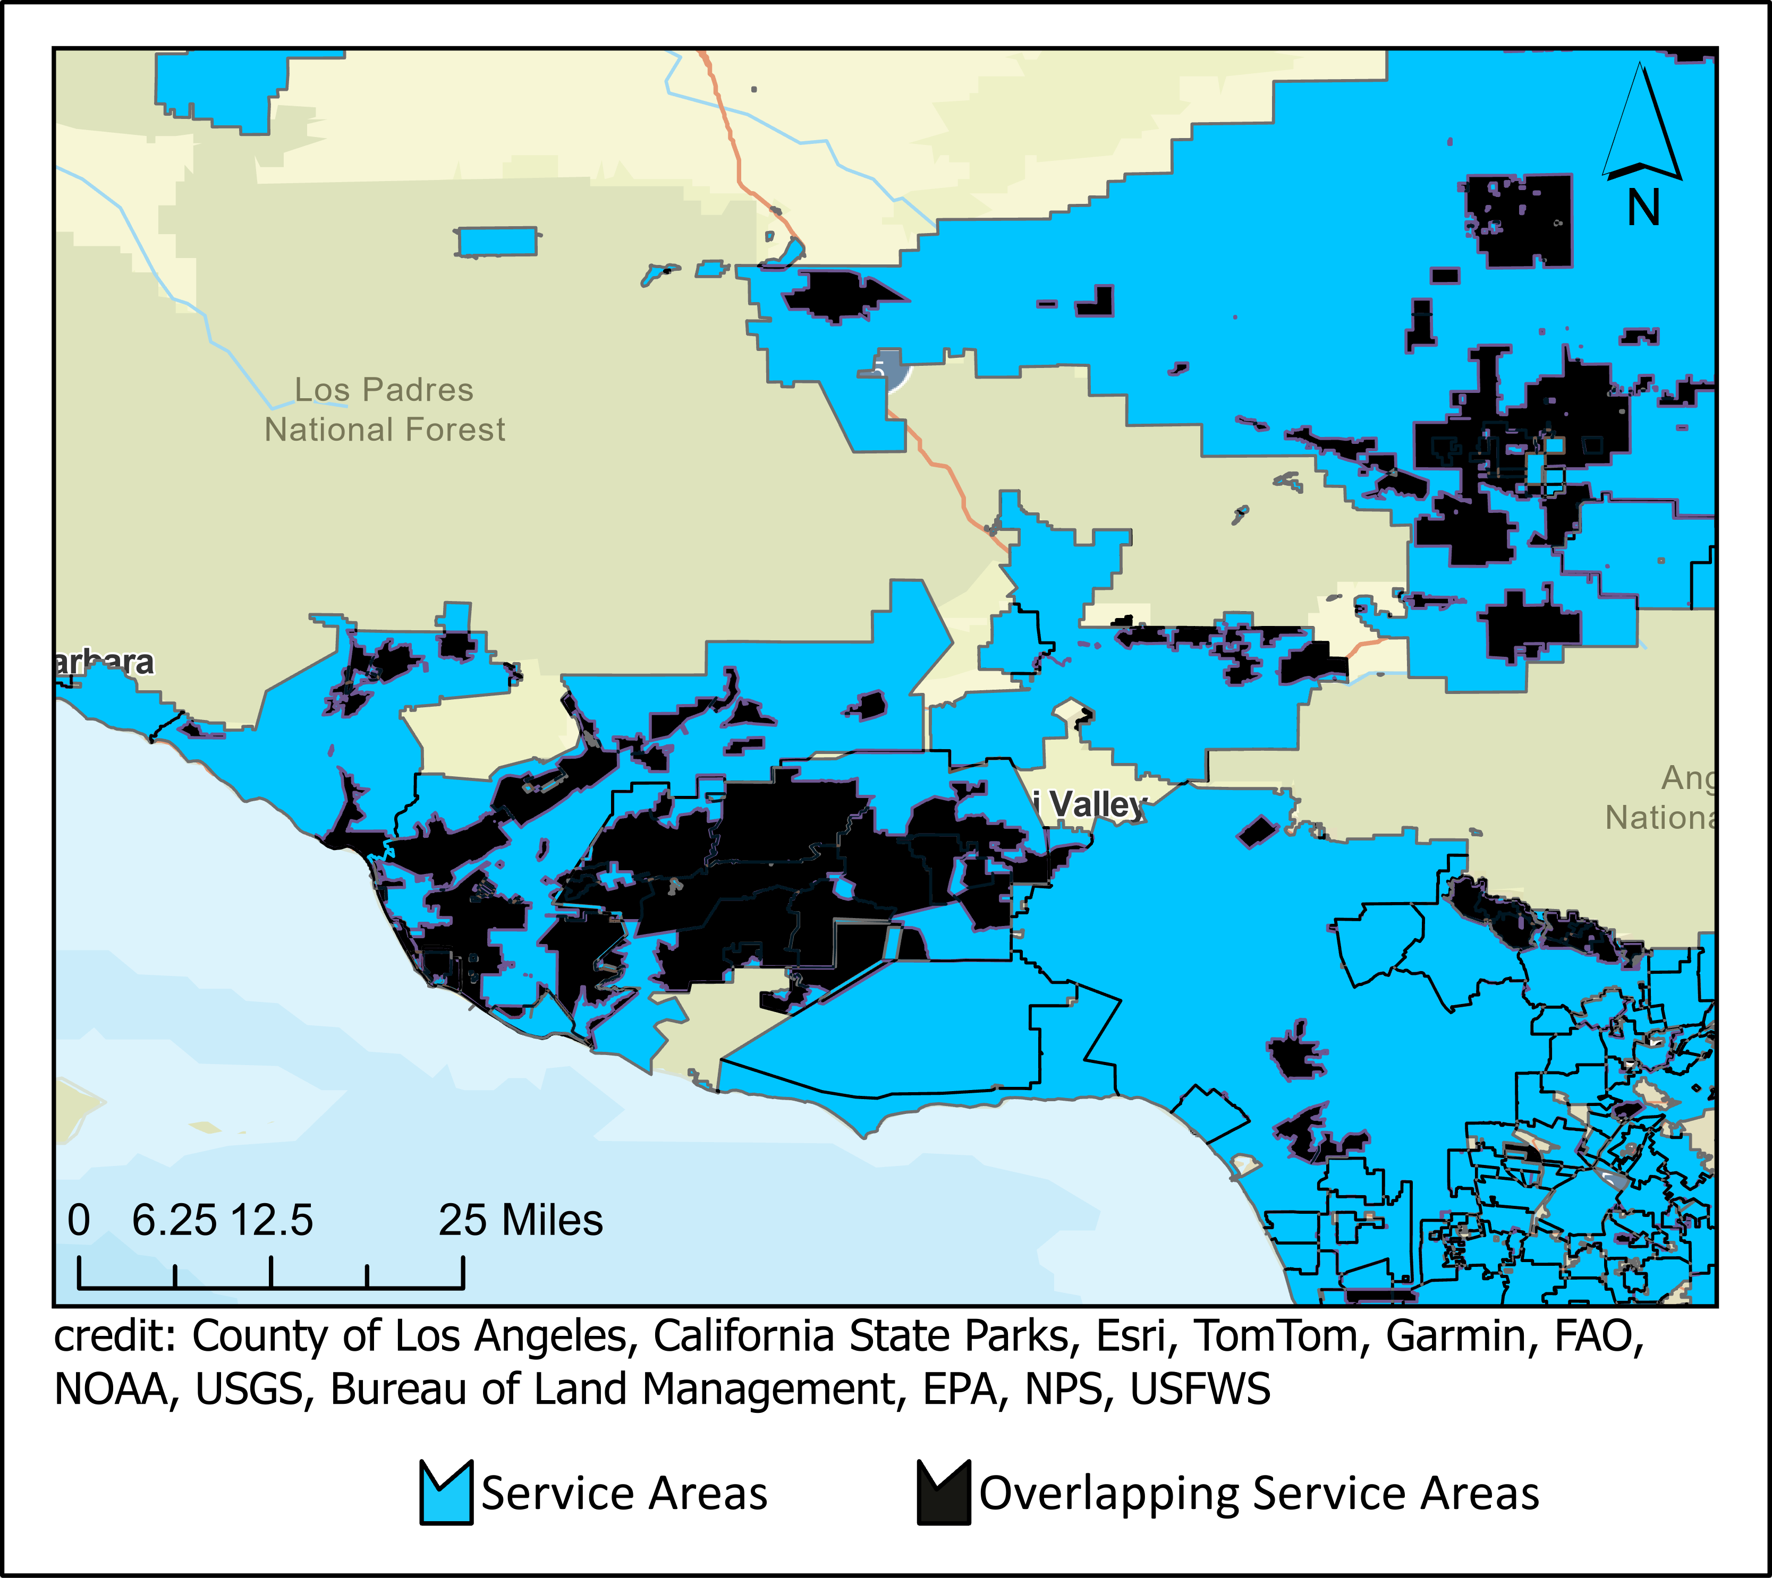

Figure 9: Map showing areas of overlap within state supplied boundaries.

## Incorrect Locations

All models have error. Trying to accurately model such a complex human phenomenon such as public drinking water infrastructure is difficult. The drivers that manifest a public drinking infrastructure—economic, social, environmental—is also complex and varies from state-to-state, community-to-community. The decision tree model was trained on 3 states and the random forest was trained on 6 states. This limited geographic range creates bias in the model and may not represent different drinking water infrastructure assumptions that may be relevant in one state, but not in others. One known issue is the poor accuracy of rural water systems serving very rural geographies. Our decision tree dataset was trained on states with a fairly urban population and states that didn’t have very many rural water districts to train the model on. South Dakota, for example, is a state with many rural water districts that cover large swaths of the rural landscape. We deliberately avoided including such districts in our training dataset because rural water districts are unique to only some states. Generally speaking, rural farmland does not have public water—so we did not want to train a model that saw farmland as being served by public water. Because of this model bias, modeled rural water districts are a known issue in our model and are typically not modeled accurately.

## Missing Systems

Why can some systems not be modeled? Besides the issue of systems being too small to model, there is another reason. The model requires geographic signals, or clues, to accurately place a service area boundary on the map. These geographic clues come primarily from two sources: 1.) SDWIS locations such as wells, intakes, and treatment plants and 2.) SDWIS reported system informationsuchas‘CityServed’. Thesesignalshelpthemodeltriangulateanappropriategeography for the service area. Approximately a dozen states don’t report “City Served’. In addition some systems don’t have corresponding SDWIS point locations or the information they provide is incorrect. For these reasons, a good portion of the systems that could not be modeled were not modeled.

For example, Figure 10 shows the vast majority of systems we could not model report less than 100 connections. Certain types of systems are also difficult to model. As represented in Figure 11, the areas we struggle to model are areas like mobile home park or subdivisions.

Systems Without Boundaries

0

250

500

750

1000

0

100

200

300

400

500

Service Connections

Count of Systems

Figure 10: Histogram of systems we do not have boundaries for by the number of service connections reported under SDWA. binwidth = 10 connections.

Percent of Systems Missing

Homeowners Association

Mobile Home Park

Municipality

Other

Residential Area

Subdivision

0

5

10

15

20

Percent

by Primary Service Area Description

Figure 11: Bar plot showing the percent of systems missing boundaries by the type of area they primarily serve.

## Kentucky

According to the state of Kentucky, about 95% of Kentuckians have access to public drinking water (Water 2022). Kentucky is relatively unique in the broad reach of their water systems to rural areas. While Kentucky does not publish service area boundaries. We received water line data from the state of kentucky, associated with PWSIDs, which delineated the main water lines. To delineate service areas, Voronoi polygons (also known as Thiessen polygons) were generated from service line data. It should be noted that the Voronoi polygons were derived from state supplied data, but the polygons themselves are not state supplied.

## Florida

For some state supplied boundaries in Florida, one polygon was associated with multiple PWSIDs. We are unable to disaggregate these multiple systems from their single geography. For these features in the dataset, you will see multiple PWSIDs within the ‘PWSID’ field.

# Code and Additional Resources

The data curation, modeling and analysis for this work was done using R (R Core Team 2022) and R Studio (Posit team 2023). All code can be viewed in the EPA agency GitHub page available at: [https://github.com/USEPA/ORD_SAB_Model.](https://github.com/USEPA/ORD_SAB_Model) Additional information is also available in this repository such as source information for boundary data obtained from state and utility sources.

To view or download the data, visit the [Service Area web application.](https://epa.maps.arcgis.com/apps/webappviewer/index.html?id=5a9963ca7a594fbd9b0df40050ed704e)

# Appendix

## Table of systems by Primacy Agency and Method

|  |  |  |  |  |  |
| --- | --- | --- | --- | --- | --- |
| Random Forest | Decision Tree | OSM | Parcel | State | Census Place |
| EPA Region 1 |  |  |  |  |  |
| 1 | 0 | 0 | 0 | 0 | 0 |
| EPA Region 10 |  |  |  |  |  |
| 60 | 11 | 0 | 0 | 0 | 0 |
| EPA Region 4 |  |  |  |  |  |
| 12 | 0 | 0 | 0 | 0 | 0 |
| EPA Region 5 |  |  |  |  |  |
| 43 | 14 | 0 | 0 | 0 | 0 |
| EPA Region 6 |  |  |  |  |  |
| 38 | 3 | 0 | 0 | 0 | 0 |
| EPA Region 7 |  |  |  |  |  |
| 7 | 1 | 0 | 0 | 0 | 0 |
| EPA Region 8 |  |  |  |  |  |
| 70 | 21 | 0 | 0 | 0 | 0 |
| EPA Region 9 |  |  |  |  |  |
| 143 | 9 | 0 | 0 | 0 | 0 |
| AK |  |  |  |  |  |
| 121 | 145 | 2 | 13 | 0 | 0 |
| AL |  |  |  |  |  |
| 409 | 77 | 1 | 0 | 2 | 0 |
| AR |  |  |  |  |  |
| 3 | 0 | 0 | 0 | 670 | 0 |
| AZ |  |  |  |  |  |
| 25 | 0 | 1 | 3 | 707 | 0 |
| CA |  |  |  |  |  |
| 25 | 0 | 0 | 0 | 2812 | 0 |
| CO |  |  |  |  |  |
| 670 | 28 | 13 | 14 | 3 | 0 |

CT

|  |  |  |  |  |  |
| --- | --- | --- | --- | --- | --- |
| 22 | 2 | 0 | 0 | 448 | 0 |
| DC |  |  |  |  |  |
| 1 | 0 | 0 | 0 | 1 | 0 |
| DE |  |  |  |  |  |
| 146 | 12 | 9 | 11 | 0 | 0 |
| FL |  |  |  |  |  |
| 860 | 56 | 13 | 1 | 464 | 0 |
| GA |  |  |  |  |  |
| 1283 | 91 | 6 | 24 | 3 | 0 |
| HI |  |  |  |  |  |
| 83 | 15 | 0 | 0 | 0 | 0 |
| IA |  |  |  |  |  |
| 855 | 114 | 11 | 8 | 2 | 0 |
| ID |  |  |  |  |  |
| 544 | 27 | 15 | 5 | 2 | 0 |
| IL |  |  |  |  |  |
| 1445 | 138 | 34 | 17 | 0 | 0 |
| IN |  |  |  |  |  |
| 499 | 116 | 25 | 105 | 2 | 0 |
| KS |  |  |  |  |  |
| 61 | 5 | 4 | 3 | 781 | 0 |
| KY |  |  |  |  |  |
| 7 | 0 | 0 | 0 | 370 | 0 |
| LA |  |  |  |  |  |
| 779 | 31 | 0 | 8 | 1 | 0 |
| MA |  |  |  |  |  |
| 437 | 6 | 0 | 15 | 2 | 0 |
| MD |  |  |  |  |  |
| 324 | 25 | 10 | 19 | 0 | 0 |
| ME |  |  |  |  |  |
| 266 | 21 | 2 | 7 | 0 | 0 |
| MI |  |  |  |  |  |

|  |  |  |  |  |  |
| --- | --- | --- | --- | --- | --- |
| 1052 | 120 | 9 | 43 | 2 | 0 |
| MN |  |  |  |  |  |
| 789 | 83 | 8 | 28 | 0 | 0 |
| MO |  |  |  |  |  |
| 1196 | 73 | 3 | 0 | 0 | 1 |
| MS |  |  |  |  |  |
| 585 | 36 | 0 | 0 | 361 | 0 |
| MT |  |  |  |  |  |
| 471 | 29 | 7 | 89 | 1 | 0 |
| NC |  |  |  |  |  |
| 1084 | 20 | 7 | 145 | 483 | 0 |
| ND |  |  |  |  |  |
| 247 | 39 | 0 | 0 | 0 | 0 |
| NE |  |  |  |  |  |
| 496 | 62 | 5 | 1 | 0 | 0 |
| NH |  |  |  |  |  |
| 40 | 0 | 0 | 2 | 658 | 0 |
| NJ |  |  |  |  |  |
| 4 | 1 | 0 | 0 | 560 | 0 |
| NM |  |  |  |  |  |
| 26 | 1 | 0 | 0 | 532 | 0 |
| NN |  |  |  |  |  |
| 114 | 8 | 0 | 0 | 4 | 0 |
| NV |  |  |  |  |  |
| 132 | 20 | 2 | 5 | 1 | 0 |
| NY |  |  |  |  |  |
| 1079 | 96 | 2 | 338 | 308 | 0 |
| OH |  |  |  |  |  |
| 847 | 104 | 39 | 99 | 1 | 0 |
| OK |  |  |  |  |  |
| 748 | 47 | 1 | 0 | 0 | 0 |
| OR |  |  |  |  |  |
| 601 | 26 | 27 | 99 | 0 | 0 |

PA

|  |  |  |  |  |  |
| --- | --- | --- | --- | --- | --- |
| 86 | 12 | 3 | 0 | 1770 | 0 |
| RI |  |  |  |  |  |
| 40 | 1 | 0 | 9 | 31 | 0 |
| SC |  |  |  |  |  |
| 419 | 51 | 3 | 31 | 2 | 0 |
| SD |  |  |  |  |  |
| 355 | 35 | 2 | 3 | 0 | 0 |
| TN |  |  |  |  |  |
| 16 | 1 | 0 | 0 | 445 | 0 |
| TX |  |  |  |  |  |
| 71 | 2 | 0 | 0 | 4538 | 0 |
| UT |  |  |  |  |  |
| 8 | 0 | 0 | 0 | 485 | 0 |
| VA |  |  |  |  |  |
| 799 | 43 | 4 | 22 | 0 | 0 |
| VT |  |  |  |  |  |
| 283 | 21 | 4 | 23 | 0 | 0 |
| WA |  |  |  |  |  |
| 380 | 7 | 0 | 0 | 1747 | 0 |
| WI |  |  |  |  |  |
| 768 | 107 | 21 | 12 | 2 | 0 |
| WV |  |  |  |  |  |
| 139 | 9 | 0 | 11 | 253 | 1 |
| WY |  |  |  |  |  |
| 226 | 17 | 4 | 2 | 0 | 0 |
| NA |  |  |  |  |  |
| 21 | 0 | 0 | 0 | 45 | 0 |

# References

Act, Safe Drinking Water. 1974. “Safe Drinking Water Act.” In *Enacted by the 93rd United States Congress. Effective*. Vol. 88.

Dorman, Michael. 2022. *Nngeo: K-Nearest Neighbor Join for Spatial Data*. [https://CRAN.Rproject.org/package=nngeo](https://CRAN.R-project.org/package=nngeo).

EPA, U. S. 2023. “Providing Safe Drinking Water in America: National Public Water Systems Compliance Report.” [https://www.epa.gov/compliance/providing-safe-drinking-water-americanational-public-water-systems-compliance-report](https://www.epa.gov/compliance/providing-safe-drinking-water-america-national-public-water-systems-compliance-report).

EPA, US. 2022. “Information about Public Water Systems.” [https://www.epa.gov/dwreginfo/ information-about-public-water-systems](https://www.epa.gov/dwreginfo/information-about-public-water-systems).

HIFLD. 2023. “Homeland Infrastructure Foundation-Level Data.” [https://services1.arcgis.com/ Hp6G80Pky0om7QvQ/arcgis/rest/services/Mobile_Home_Parks/FeatureServer/0](https://services1.arcgis.com/Hp6G80Pky0om7QvQ/arcgis/rest/services/Mobile_Home_Parks/FeatureServer/0).

Manson, Steven M, Jonathan Schroeder, David Van Riper, Katherine Knowles, Tracy Kugler, Finn Roberts, and Steven Ruggles. 2023. “IPUMS National Historical Geographic Information System: Version 18.0.”

Microsoft. 2023. “US Building Footprints.” [https://github.com/microsoft/USBuildingFootprints? tab=readme-ov-file](https://github.com/microsoft/USBuildingFootprints?tab=readme-ov-file).

Murray, Andrew, Alexander Hall, James Weaver, and Fran Kremer. 2021. “Methods for Estimating Locations of Housing Units Served by Private Domestic Wells in the United States Applied to 2010.” *JAWRA*.

Posit team. 2023. *RStudio: Integrated Development Environment for r*. Boston, MA: Posit Software, PBC. [http://www.posit.co/.](http://www.posit.co/)

R Core Team. 2022. *R: A Language and Environment for Statistical Computing*. Vienna, Austria: R Foundation for Statistical Computing. [https://www.R-project.org/.](https://www.R-project.org/)

REGRID. 2023. “REGRID Parcels Feature Service.” [https://epa.maps.arcgis.com/home/item.html? id=75da303642e74f4b8b25caa6c1bbfad0](https://epa.maps.arcgis.com/home/item.html?id=75da303642e74f4b8b25caa6c1bbfad0).

Toccalino, Patricia L, Julia E Norman, and Kerie J Hitt. 2010. “Quality of Source Water from PublicSupply Wells in the United States, 1993-2007.” US Geological Survey.

Water, Kentucky Division of. 2022. “Drinking Water.” [https://eec.ky.gov/Environmental-Protection/ Water/Drinking/Pages/Drinking%20Water.aspx](https://eec.ky.gov/Environmental-Protection/Water/Drinking/Pages/Drinking%20Water.aspx).

1. This is similar to the EPA definition of a public water provider: “A public water system provides water for human consumption through pipes or other constructed conveyances to at least 15 service connections or serves an average of at least 25 people for at least 60 days a year.” https://www.epa.gov/dwreginfo/information-about-public-water-systems